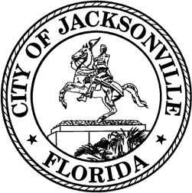

OFFICE OF THE CITY COUNCIL

COUNCIL MEMBER JIMMY PELUSO  DISTRICT 7  OFFICE (904) 255- 5207  FAX (904) 255-5230 | SUITE 425, CITY HALL  117 WEST DUVAL STREET JACKSONVILLE, FL 32202  E-MAIL: JPELUSO@COJ.NET

MEETING NOTICE

Notice is hereby given that Council Member Jimmy Peluso will host a noticed meeting on January 28, 2026, at 2:00 p.m., in the Lynwood Roberts Room on the first floor of City Hall at 117 West Duval Street, Jacksonville, FL 32202 to discuss the next steps in a landlord registry and other matters. This meeting is open to the public and all interested parties are welcome.

For additional information, please contact Brooks Dame at bdame@coj.net or (904) 255-5135.

Accommodation Requests:
Pursuant to the American with Disabilities Act, accommodations for persons with disabilities are available upon request. Please allow 1-2 business days for a notification to process; last- minute requests will be accepted but may not be possible to fulfill. Please contact Disabled Services Division at: VM (904) 255-5466, TTY (904) 255-5475, or email your request to KaraT@coj.net.

JP/bd

NOTICED ON: January 22, 2026, at 4:50 p.m., pursuant to 15.103(c), Ordinance Code.

cc: Council Members and Staff
Jason Teal, Director/Council Secretary
Bernadette Smith, Chief, Legislative Services Division Teresa Eichner, Chief, Public Information Division Yvonne Mitchell, Chief, Administrative Services Division
Colleen Hampsey, Chief, Research Division CITYC@COJ.NET
Electronic Notice Kiosk – 1st Floor City Hall Public Notice System – City Council Web Page Media Box
File Copy

